Creating VM using Vagrant

1. Create a repo and initialise vagrant in it.

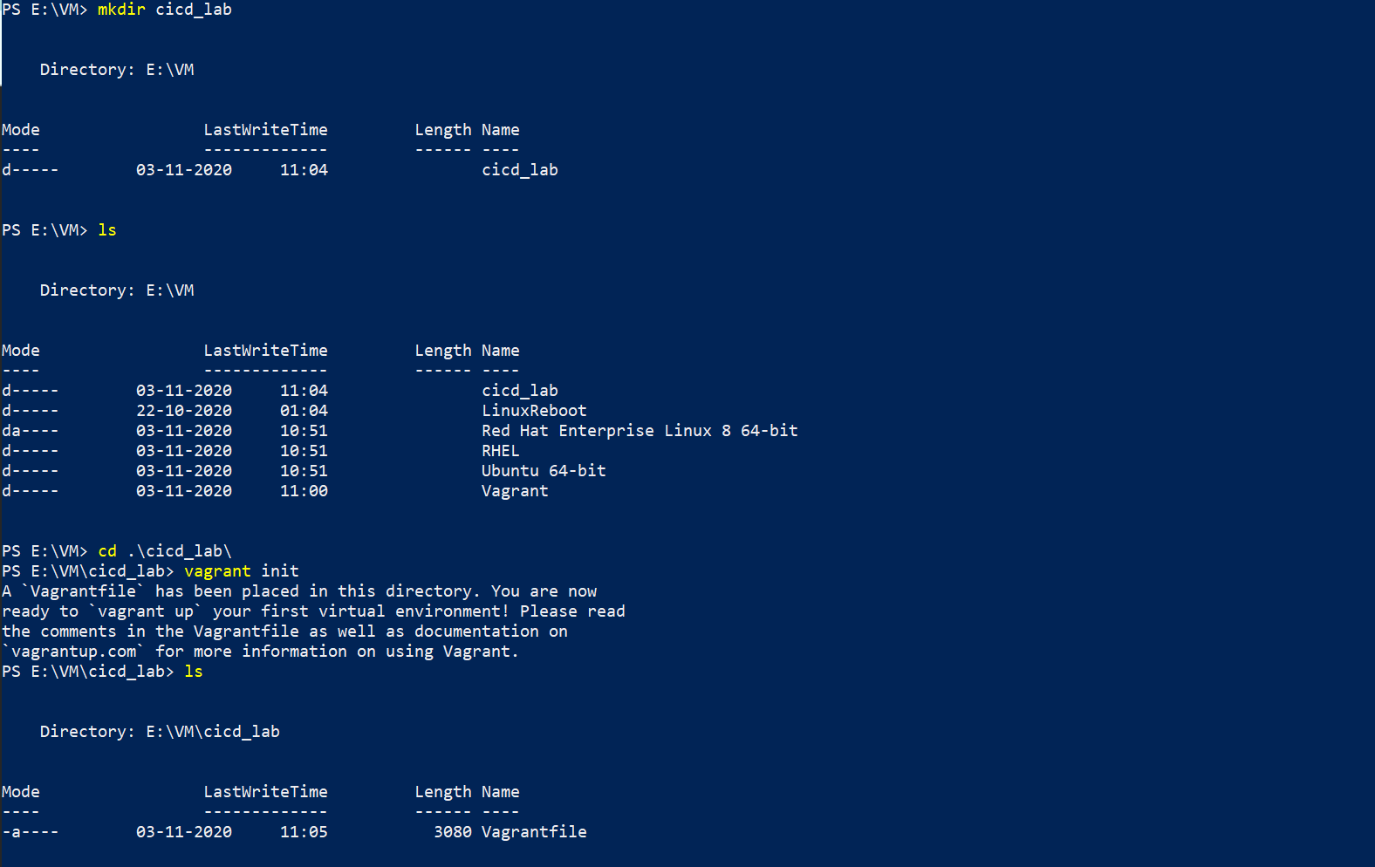

1. Configure Vagantfile.

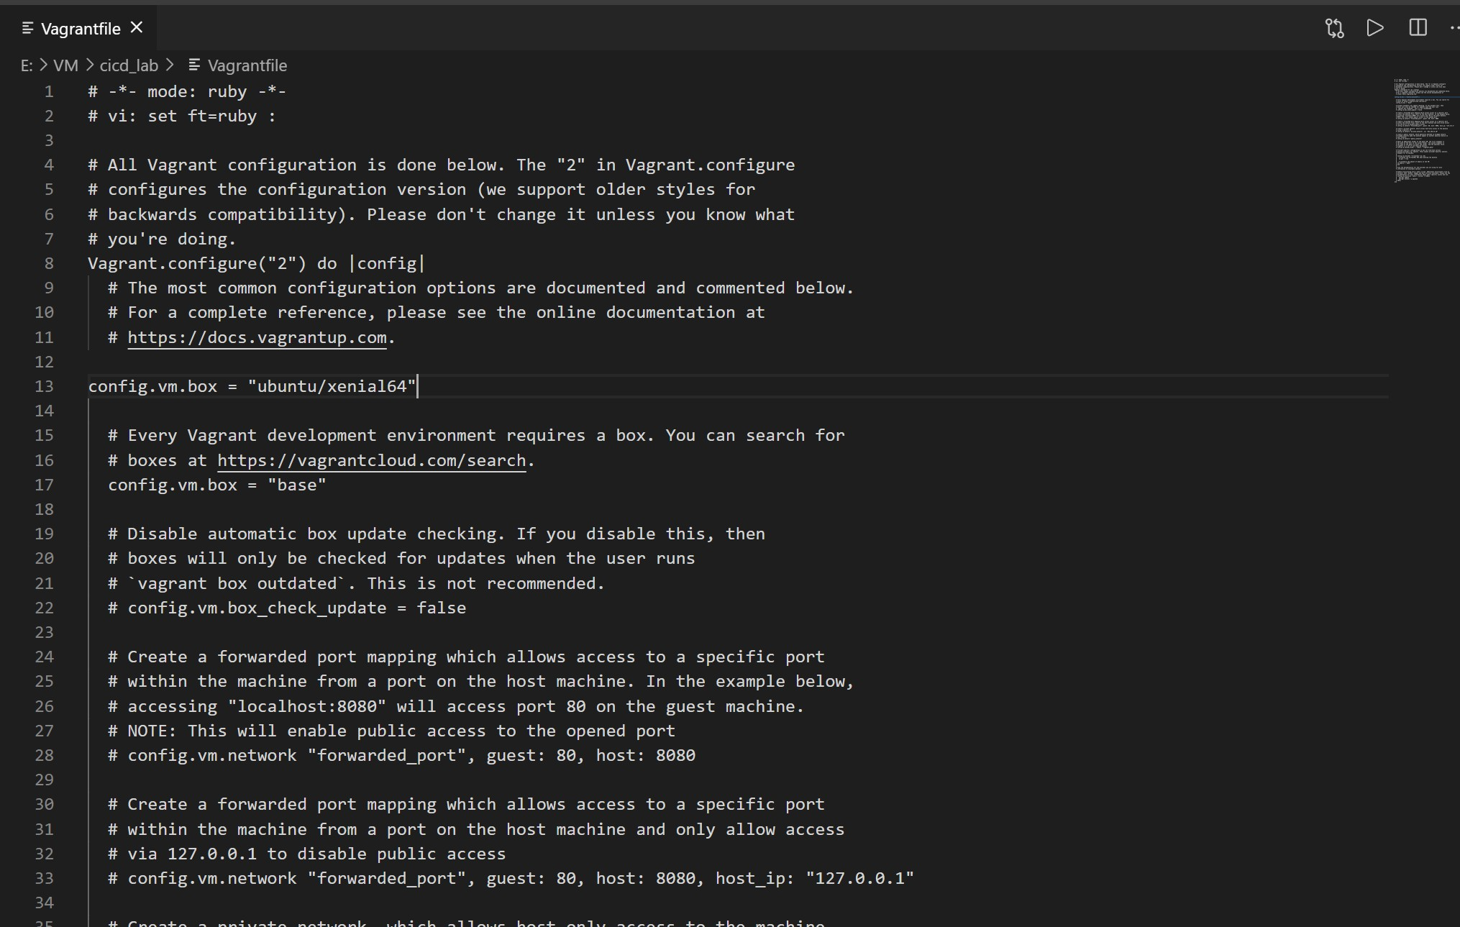

1. Make the machine up using **vagrant up** command.

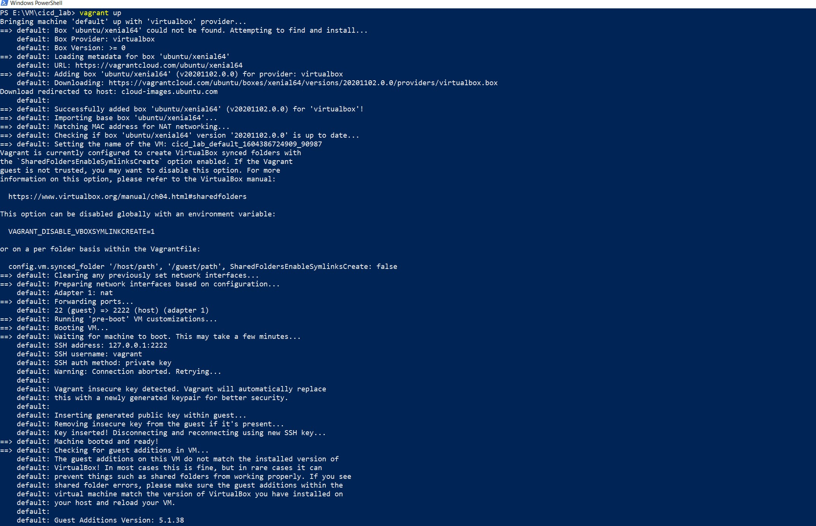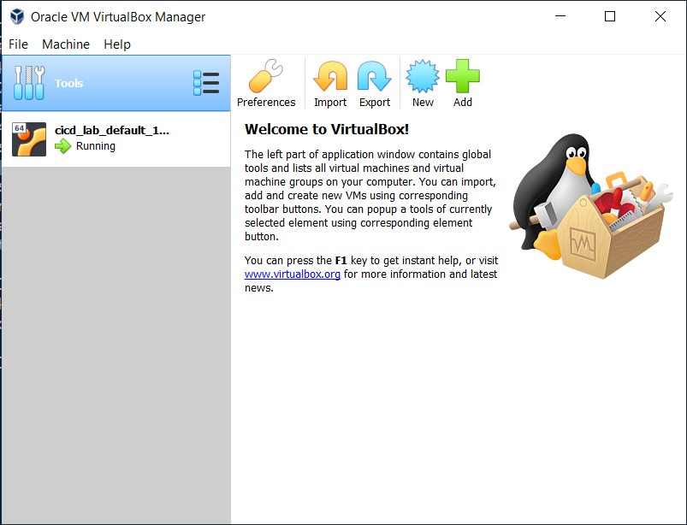

1. Connect via **vagrant ssh** command and perform the tasks on the machine.

